This document will take readers through the architecture and design of the King of Tokyo (KOT) game which was developed using React framework, Python and Django framework

KOT THE GAME -

King of Tokyo (React &Python with Django game development)

**Developers: Cameron Baffuto, Chris Vennel, Derek McCammond, Gerardo Faia, Keith Aubin, Lakshmi Maguluri, Samridh Prasad, Shubhra Mahey, Taiwo Oyesanmi**

Table of Contents

1. Introduction and Background 2

2. Architecture 2

Figure 1 - Game Architecture 2

3. Database Model 3

Figure 2 - Game database model 3

4. Tools Leveraged 4

5. Setup 4

6. Sample Game Play 4

*Figure 3 - Game start Page* 4

*Figure 4 - Connect DB Browser for SQLite tool* 5

*Figure 5 - Browse Data in DB Browser for SQLite tool (game_*)* 5

*Figure 6 – Create first User* 6

*Figure 7 – Add first User to Room Enter Room* 6

*Figure 8 – Game is opens in Room with Player* 7

*Figure 9 – Game Room is shown in the database (game-game)* 7

*Figure 10 – User is shown in the database (game_user)* 8

*Figure 11 – Create second User* 8

*Figure 12 – Add second User to Room Enter Room* 9

*Figure 13 – second User is shown in the database (game_user)* 9

*Figure 14 – Game starts* 10

*Figure 15 – Roll Dice* 10

*Figure 16 – Confirm Dice Roll in database (game_dice)* 11

*Figure 17 – Sweep Store* 11

*Figure 18 – Confirm store sweep in database (game_play)* 12

7. References 12

# Introduction and Background

King of Tokyo (KOT) is an award-winning best-selling card and dice boardgame by Richard Garfield developed in 2011 and published by IELLO. The rules of the game can be found at the publisher site [[1]](http://www.iellogames.com/downloads/KOT2-rulebook_EN.pdf). The game has several variants over the years and has acquired great acclaim with numerous awards and honors, list of which can be viewed by referring to game wiki at[[2]](https://en.wikipedia.org/wiki/King_of_Tokyo).

# Architecture

The game is built as a single page application leveraging React, Python and the Django framework. Below is a diagram of the game architecture.

### Figure 1 - Game Architecture

# Database Model

The game leverages Django framework which comes “out of the box” setup to communicate with the SQLite. The configuration for the database is in the settings.py file found in the game repository as shown at  [[3]](https://github.com/borisv13/kot/blob/master/backend/kot/settings.py). Django supports several databases such as MySQL, Oracle, etc. officially besides SQLite and the full list can found at [[4]](https://docs.djangoproject.com/en/3.0/ref/databases/). Below is the diagram of the database model

### Figure 2 - Game database model

# Tools Leveraged

* + - 1. PyCharm
      2. DB Browser (SQLite)

# Setup

The platform setup can be accomplished after the repository has been cloned from git to local workstation from[5]. Furthermore, a README.md file within the game repository has the setup steps which leverage the requirements.txt file in the repository

# Sample Game Play

Below are some screenshots that show game play and data entry into the backend database. Once the front end and backend servers are started as instructed in the application README.md file and then navigate to the game test URL and start the game

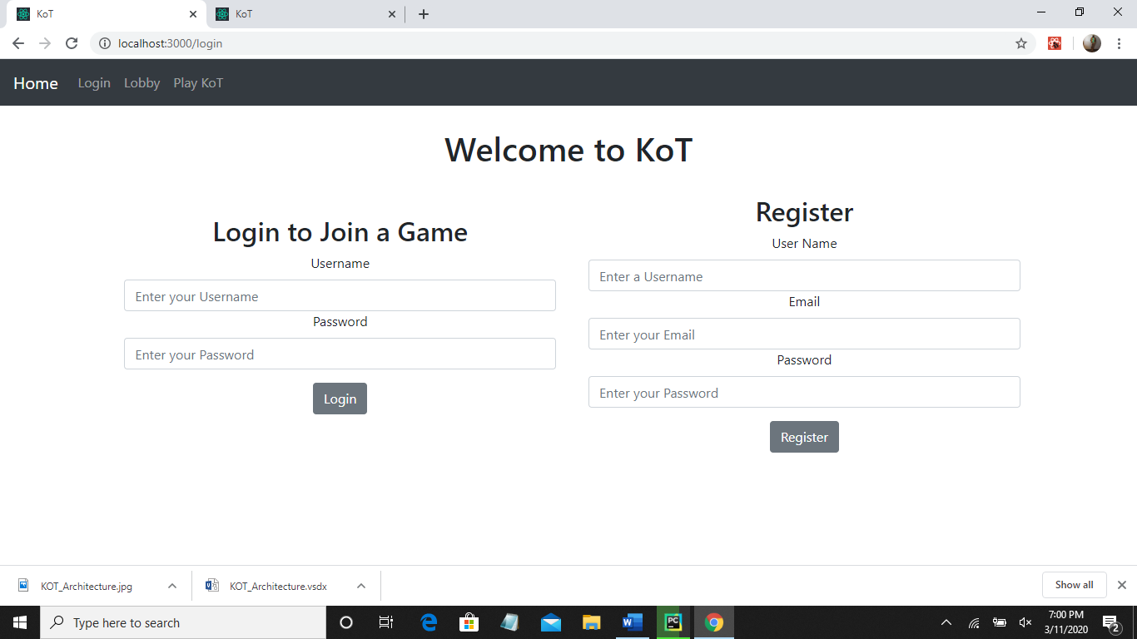

### Figure 3 - Game start Page

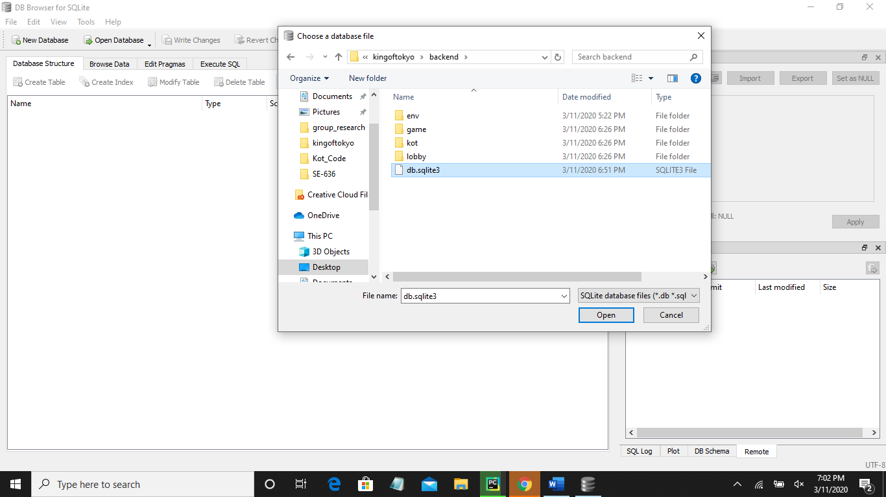

### Figure 4 - Connect DB Browser for SQLite tool

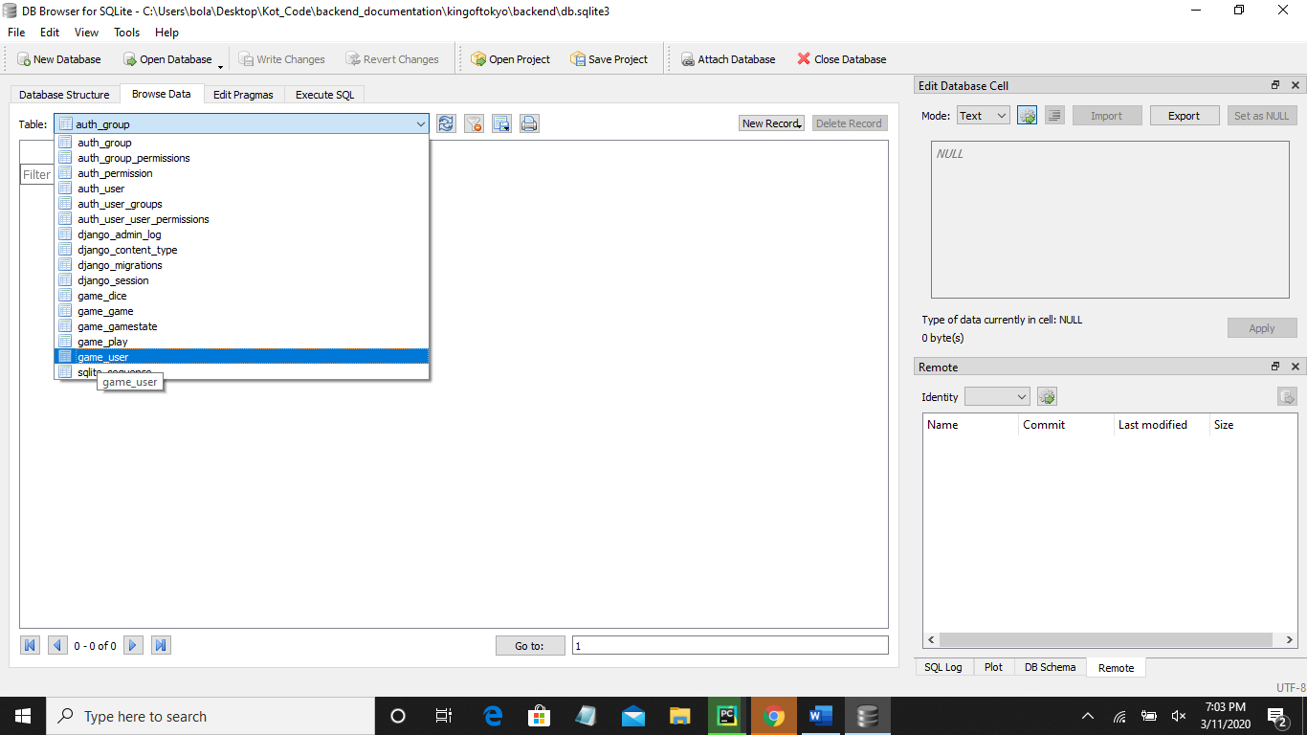

### Figure 5 - Browse Data in DB Browser for SQLite tool (game_*)

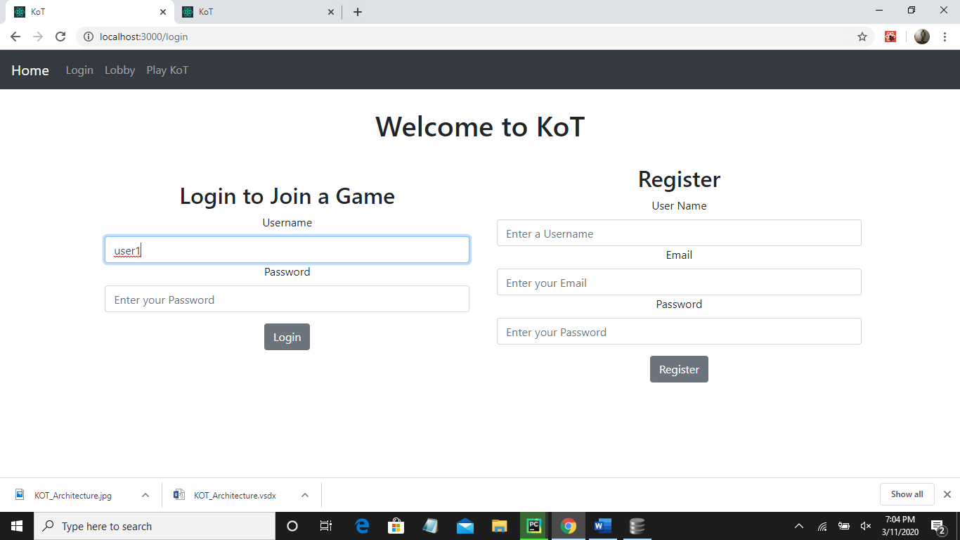

### Figure 6 – Create first User

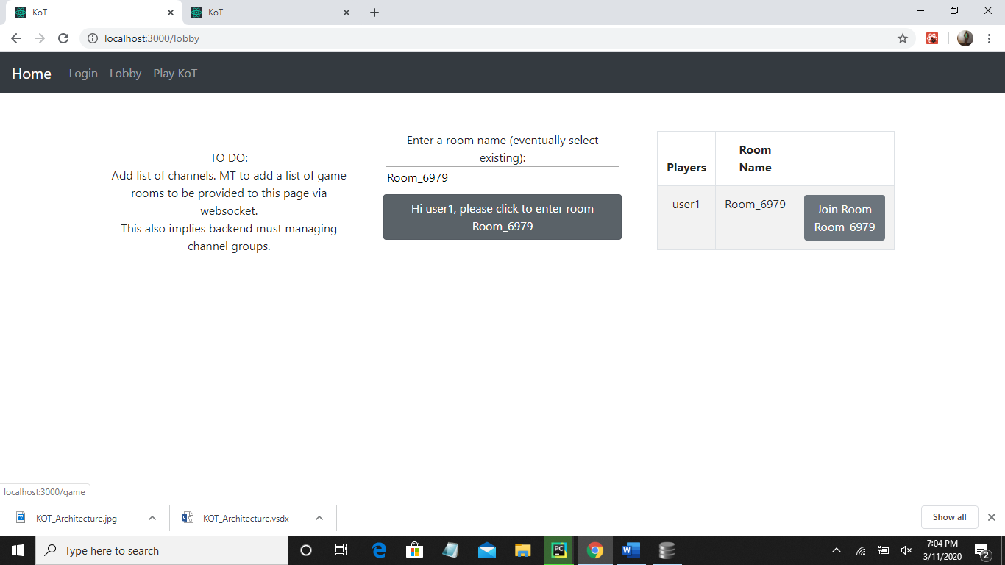

### Figure 7 – Add first User to Room Enter Room

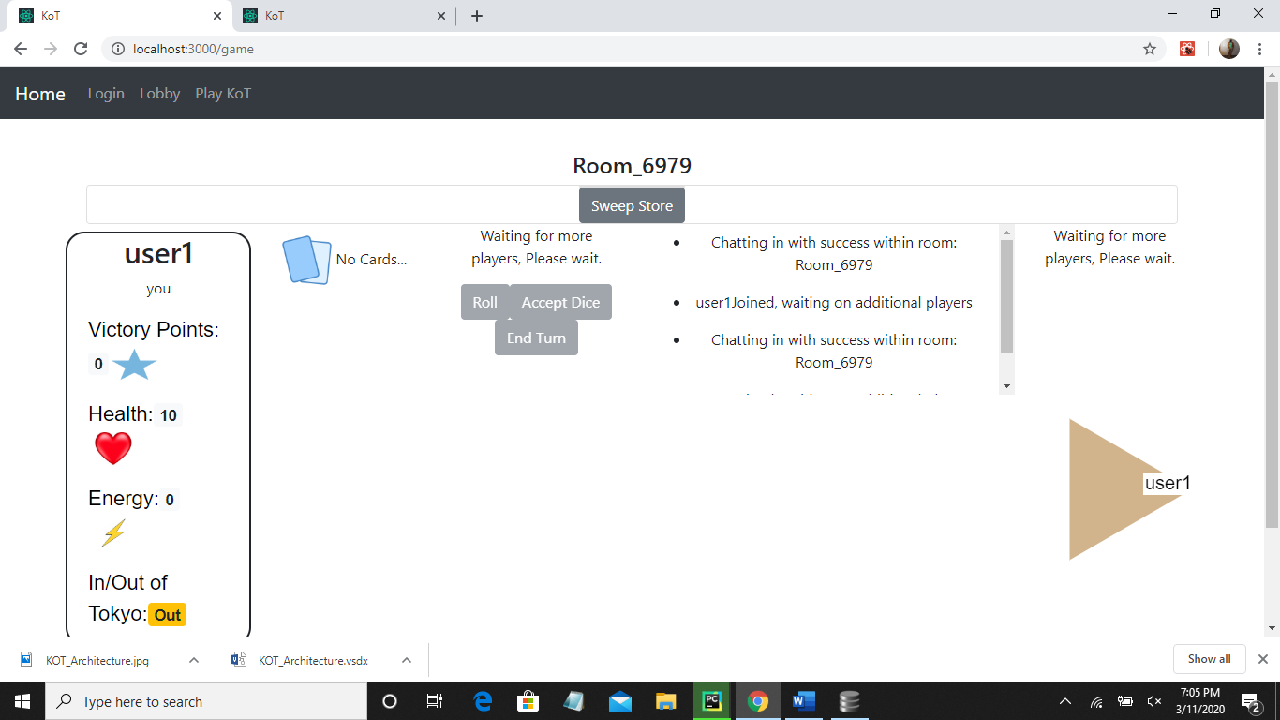

### Figure 8 – Game is opens in Room with Player

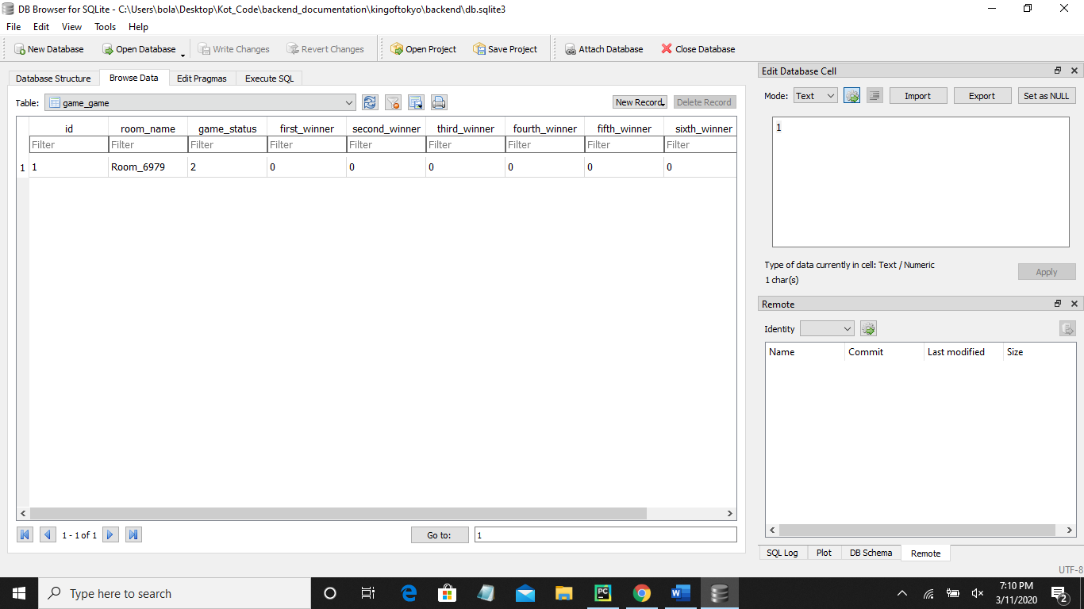

### Figure 9 – Game Room is shown in the database (game-game)

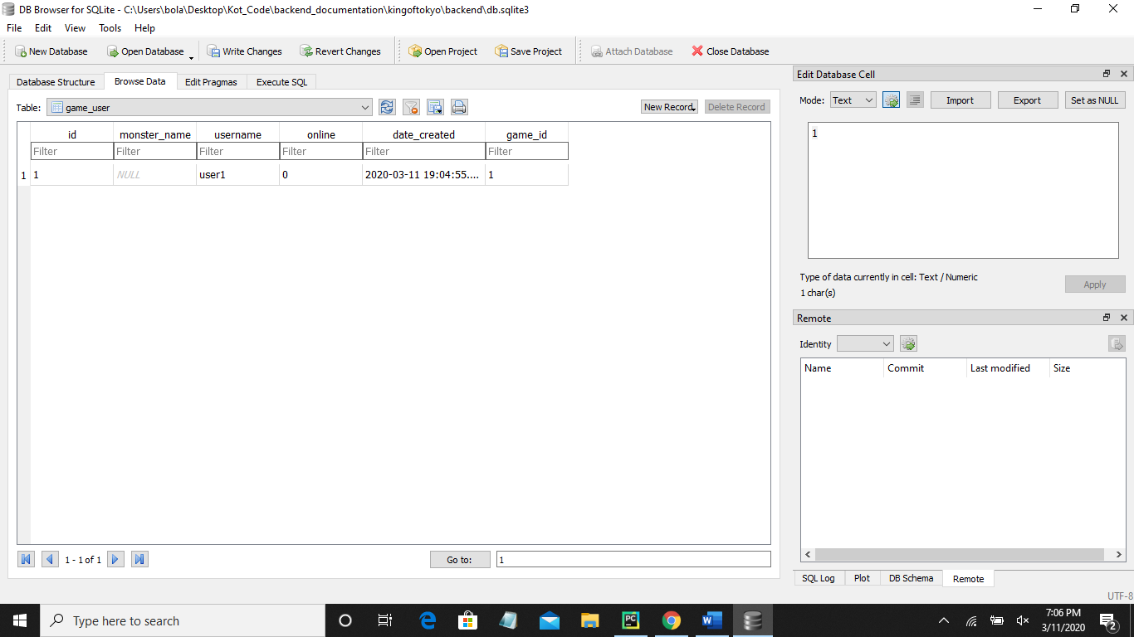

### Figure 10 – User is shown in the database (game_user)

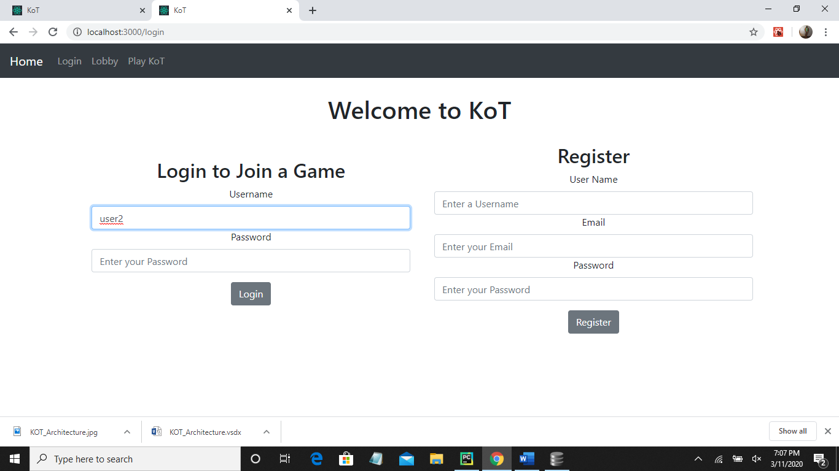

### Figure 11 – Create second User

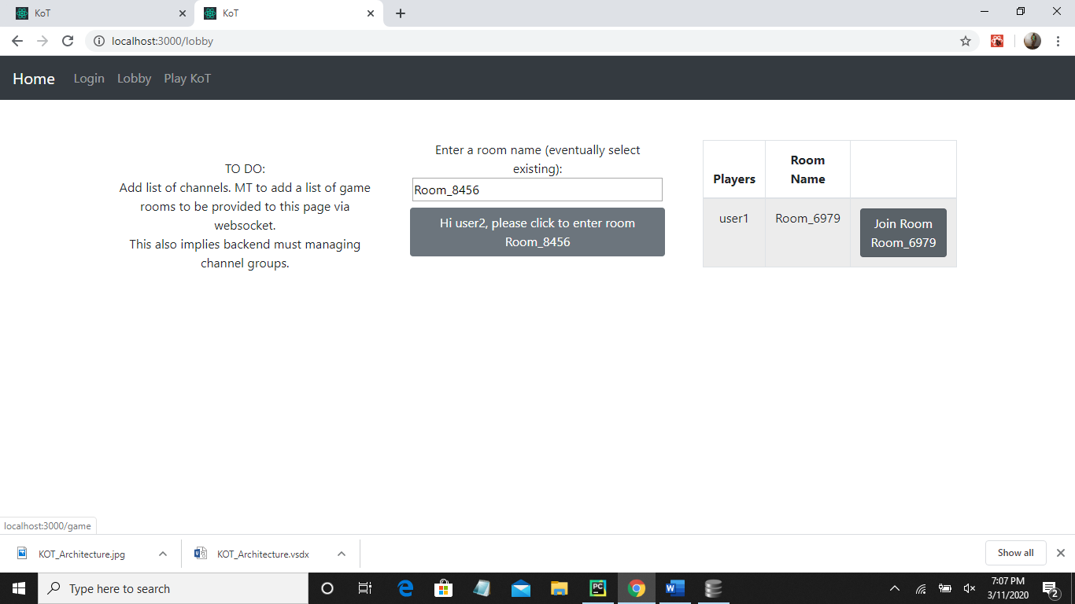

### Figure 12 – Add second User to Room Enter Room

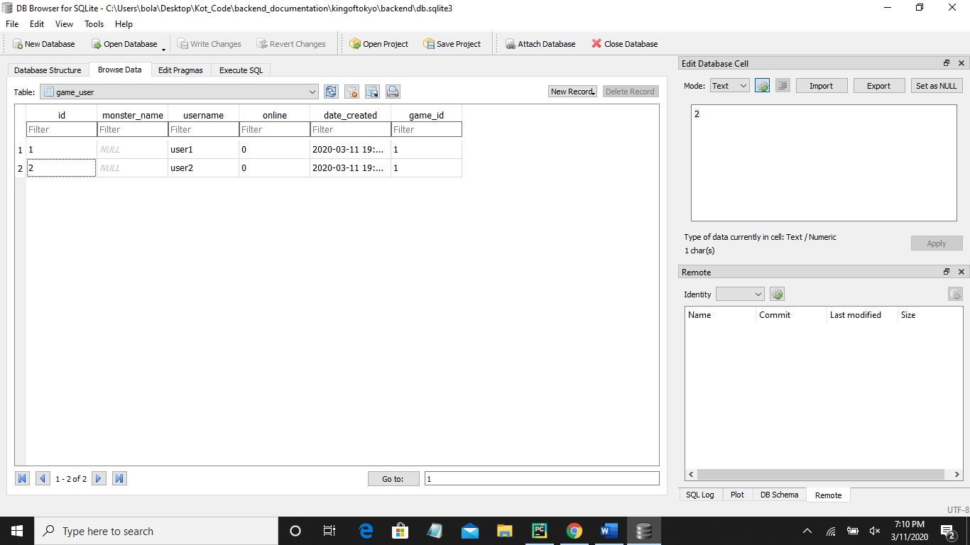

### Figure 13 – second User is shown in the database (game_user)

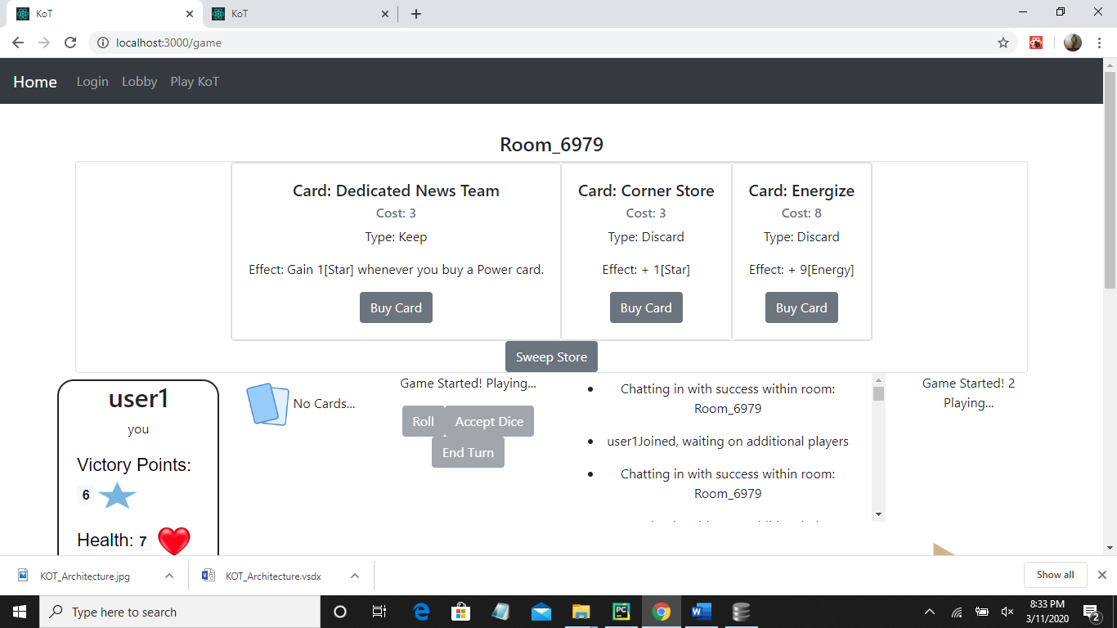

### Figure 14 – Game starts

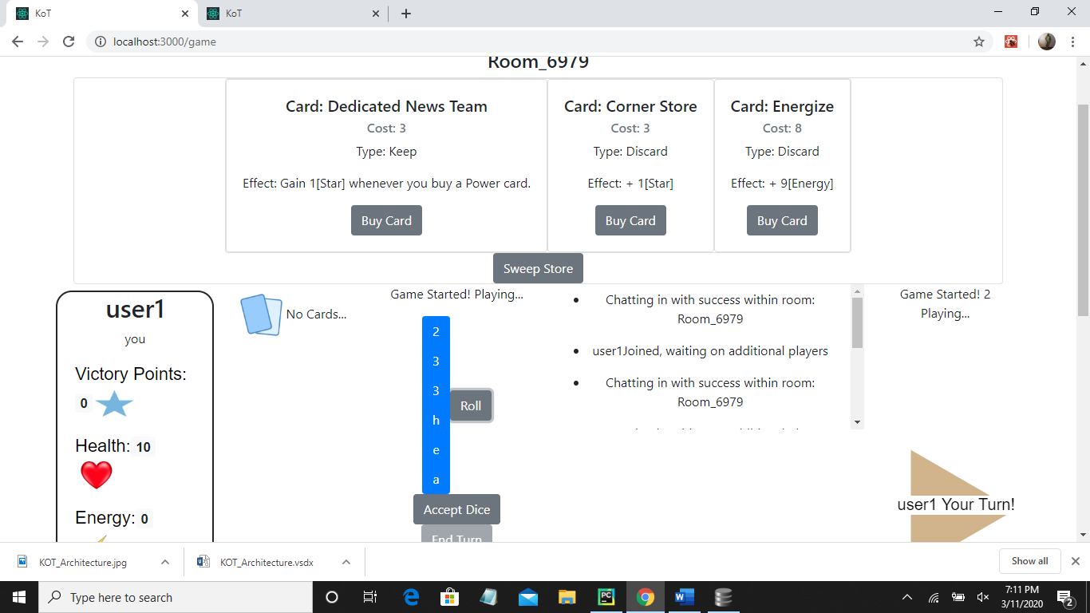

### Figure 15 – Roll Dice

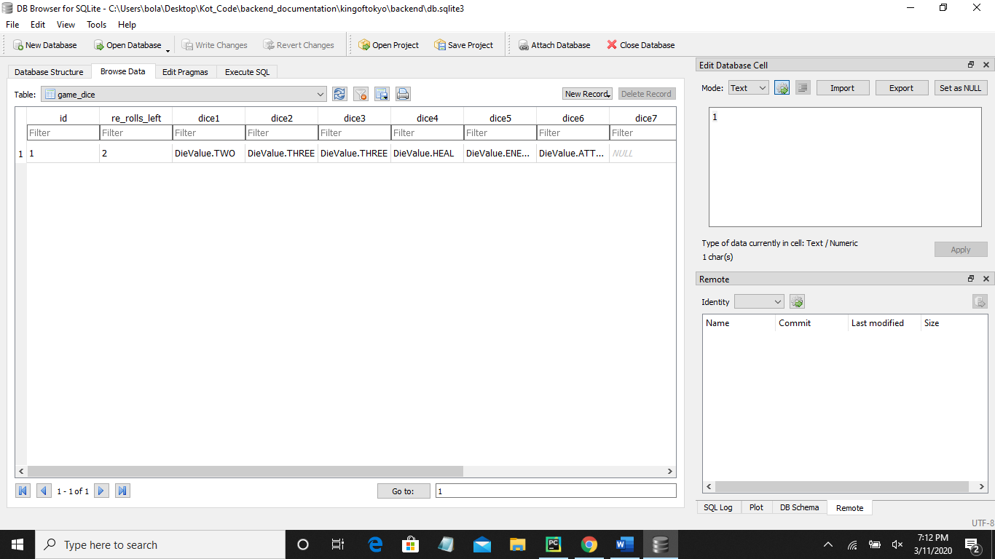

### Figure 16 – Confirm Dice Roll in database (game_dice)

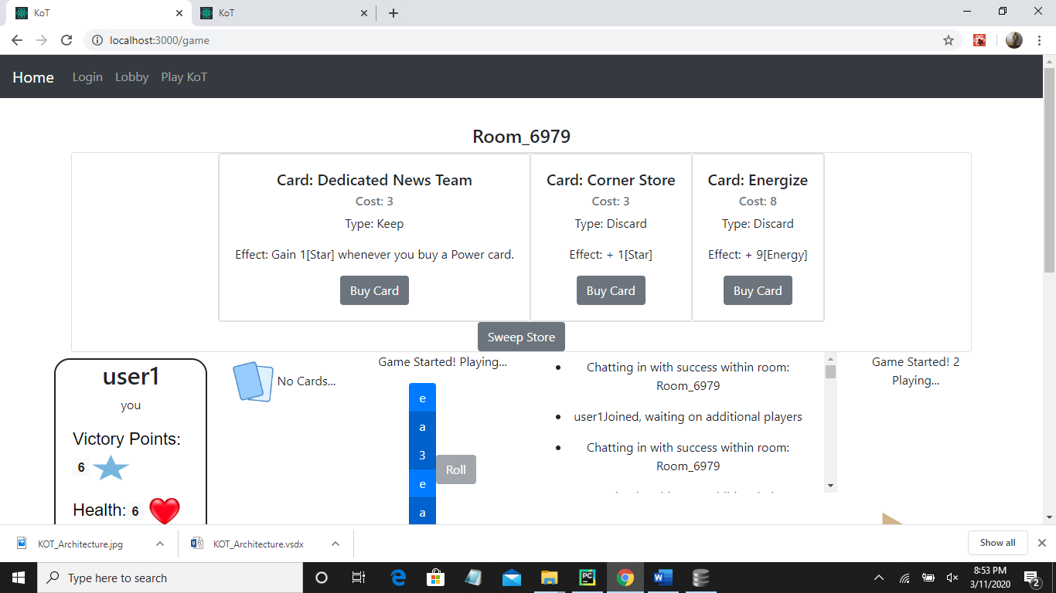

### Figure 17 – Sweep Store

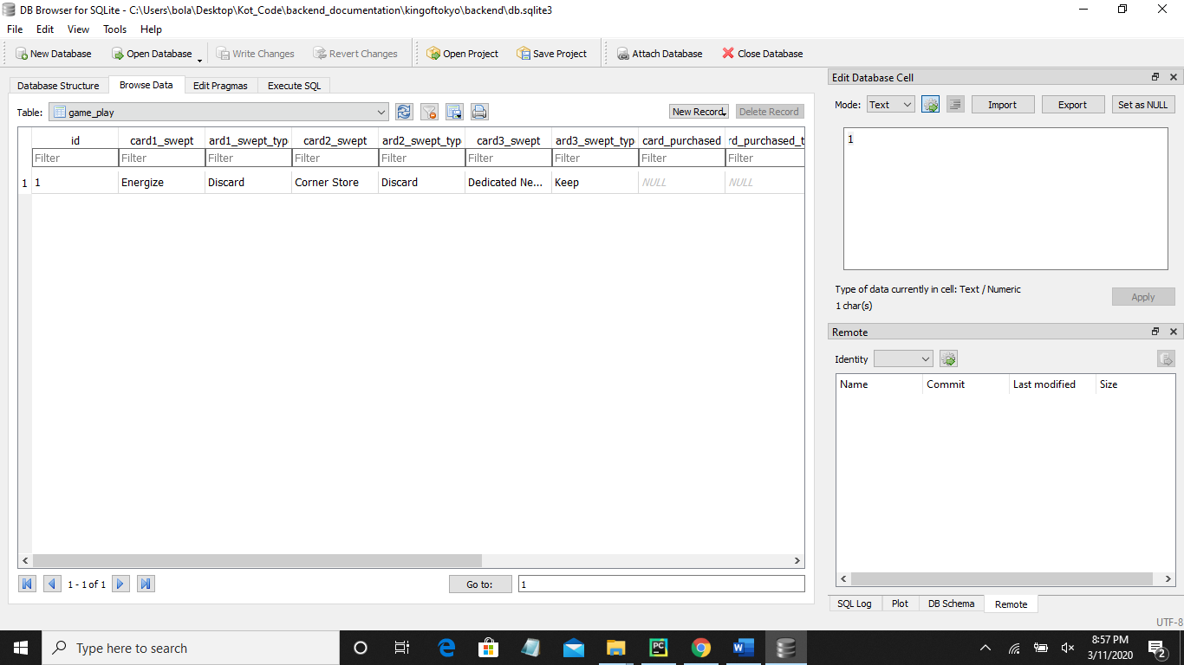

### Figure 18 – Confirm store sweep in database (game_play)

# Site References

* + - 1. <http://www.iellogames.com/downloads/KOT2-rulebook_EN.pdf>
      2. <https://en.wikipedia.org/wiki/King_of_Tokyo>
      3. <https://github.com/borisv13/kot/blob/master/backend/kot/settings.py>
      4. <https://docs.djangoproject.com/en/3.0/ref/databases/>
      5. <https://github.com/borisv13/kot.git>

[1]